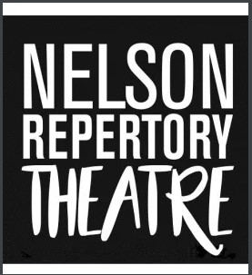

Nelson Repertory Theatre
President Job Description
Reports

In addition to the duties of all Committee members, the President shall ensure the continued operation of Nelson Repertory Theatre Incorporated Society. The President will:

- Manage the strategic direction of Nelson Repertory Theatre
- Take responsibility for ensuring the overall health of the society and its members
- Delegate tasks and responsibilities for the effective running of the group
- Chair committee and all general meetings (including the AGM). This includes setting agendas
- Ensure the constitution and policies of the society are followed
- Oversee the appointment of any sub-committees
- Act as a representative of the society in the community
- Maintain a close working relationship with Nelson Historical Theatre Trust, including the appointment of 2 Trustees.
- Oversee planning and budgeting for the year, including events, productions, and fundraisers
- Ensure the society keeps members informed, and communicating with the community and other stakeholders
- Be the arbitrator of last resort

Term
The President is elected for a one-year term at the society’s Annual General meeting.

